

**Configuring and Verifying HSRP** *v1.1*

# Introduction

Hot Standby Router Protocol (HSRP) is a Cisco proprietary protocol that provides a redundant gateway for hosts on a local subnet. HSRP allows configuration of two, or more, routers into a standby group that share an IP address and MAC address, while also providing a default gateway.

# Objective(s)

In this lab the student will:

● Configure and Verify HSRP

# Equipment/Supplies Needed

* Computer with Internet connection
* Cisco Packet Tracer
* Configuring and Verifying HSRP.PKA file

# Assignment

*Perform the steps in this lab in the order they are presented to you. Answer all questions and record the requested information in this lab file.*

**Configure Lab Network**

1. Configure the network as shown.
2. *If using Packet Tracer, the topology has already been created.*

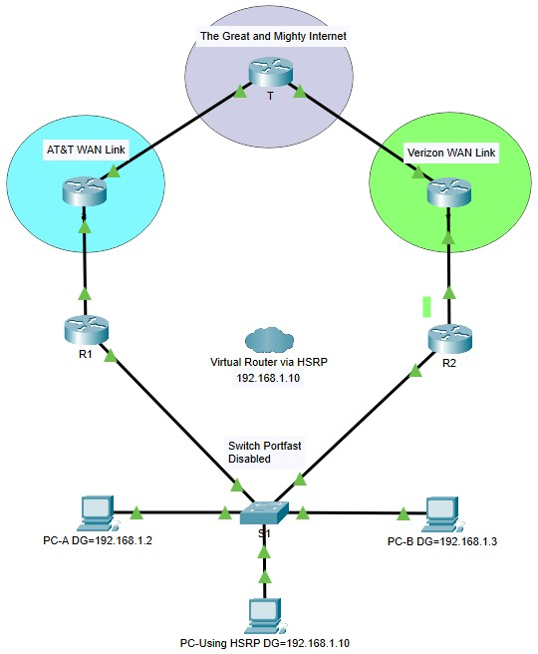

**Addressing Table**

|  |  |  |  |
| --- | --- | --- | --- |
| **Device** | **Interface** | **IP Address** | **Default Gateway** |
| Great and Mighty | Loopback 1 | 10.10.10.10 | n/a |
|  |  |  |  |
| AT&T WAN  Link | G0/1 | 192.168.2.2/24 | n/a |
| Verizon WAN Link | G0/1 | 192.168.3.2/24 | n/a |
| Virtual Router (HSRP) |  | 192.168.1.10 | n/a |
| R1 | G0/0 | 192.168.1.2/24 | n/a |
|  | G0/1 | 192.168.2.1/24 | n/a |
| R2 | G0/0 | 192.168.1.3/24 | n/a |
|  | G0/1 | 192.168.3.1/24 | n/a |
| PC-A |  | 192.168.1.100 /24 | 192.168.1.2 |
| PC-B |  | 192.168.1.101 /24 | 192.168.1.3 |
| PC-C (HSRP) |  | 192.168.1.102 /24 | 192.168.1.10 |

**Procedure**

*Perform the steps in this lab in the order they are presented to you. Answer all questions and record the requested information in a text file.*

**Note:** Attributes of an HSRP virtual mac-address

HSRP Mac address Breakdown:

**0000.0C07.AC01**

**0000.0C** = Cisco Vendor ID

**07.AC** = HSRP ID **01** = Standby Group Number

**Step 1:**

1. Configure the router’s (***HSRP1, HSRP2***) Ethernet interfaces as shown in the diagram.

*If your router does not have interfaces as depicted in diagram, change the lab as required to your router interfaces [ie. Serial 0/0 vs Serial 0/0/0 etc.] Annotate changes on your diagram to keep you on track. Remember, you can always type in* ***show ip int brief from Privileged Mode*** *to see the interface types.*

1. The computers in this lab are just connection points. No configuration is necessary.
2. The following commands set the virtual router IP, standby group and sets the interface on router **HSRP1** so that it wins the election and becomes the active router by default.

**Note:** By default, the priority is 100 but the highest priority value becomes the active router for the HSRP group. If there is a tie, the router with the highest IP address becomes the active router.

HSRP1#**config t**

HSRP1(config)#**interface G0/0**

HSRP1(config-if)#**standby 1 ip 192.168.1.10**

HSRP1(config-if)#**standby 1 priority 110**

1. The following commands set the virtual router IP and standby group on router **HSRP2**.

HSRP2#**config t**

HSRP2(config)#**interface G0/0**

HSRP2(config-if)#**standby 1 ip 192.168.1.10**

1. Verify that HSRP took effect by using the following commands: **Document your results!**

HSRP1#**show standby**

R1(config)# **do show standby**

R1(config-if)#do show standby

GigabitEthernet0/0 - Group 1

State is Active

5 state changes, last state change 02:33:07

Virtual IP address is 192.168.1.10

Active virtual MAC address is 0000.0C07.AC01

Local virtual MAC address is 0000.0C07.AC01 (v1 default)

Hello time 3 sec, hold time 10 sec

Next hello sent in 0.541 secs

Preemption enabled

Active router is local

Standby router is 192.168.1.3

Priority 105 (configured 105)

Group name is hsrp-Gig0/0-1 (default)

HSRP1#

**show standby brief**

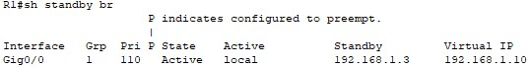

***Documented Results Below :***

**Step 2:**

1. Ping from PC’s to the Internet:
   1. Ping from PC-A to the Internet (10.10.10.10).

PC-A has a default gateway of R1 (192.168.1.2)

* 1. Ping from PC-B to the Internet (10.10.10.10).

PC-B has a default gateway of R2 (192.168.1.3)

* 1. Ping from “PC-Using HSRP” to the Internet.

This PC’s default gateway is set to the HSRP virtual IP of 192.168.1.10, protecting the default gateway.

1. Now go int R1 and power it down.
   1. Record the above ping results again.
   2. Power R1 back up and wait for results to be normal.
2. Now go to R2 and power it down.
   1. Record the above ping results again.
   2. Power R2 back up and wait for results to be normal.

**Testing HSRP Operations**

*At the bottom of your packet tracer, you will see 3 PDU tests built. These tests will ping the*

*items show below to test. You can use these PDU to view your connectivity results.*

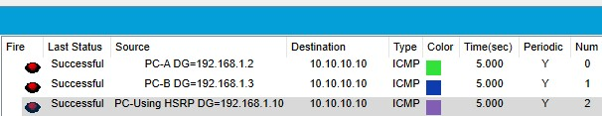

**Summary: PC-A and PC-B are vulnerable to router outages, however the PC using a HSRP enabled router as it’s gateway might see a short outage, but should recover.**

Please summarize your observations.

**What would happen if all the PC’s were set to the new default gateway offered in DHCP?**

If completing this lab **online**, save the **Packet Tracer file as 5.1.2 Configuring and Verifying HSRP** as well as this Lab document with your answers embedding. If completing this lab **in class**, save your **show standby, show standby brief and show run commands in a document titled 5.1.2 Configuring and Verifying HSRP.**

**Rubric**

|  |  |  |
| --- | --- | --- |
| Concerns  Working Towards Proficiency | Criteria  Standards for This Competency | Accomplished  Evidence of Mastering Competency |
|  | Criteria #1: Configure the HSRP1 router (25 pts) | Configure HSRP protocol on the HSRP1 router |
|  | Criteria #2: Configure the HSRP2 router (25 pts) | Configure HSRP protocol on the HSRP2 router |
|  | Criteria #3: Verify HSRP (25 pts) | Verify HSRP using show commands - Results Documented |
|  | Criteria #4: Test HSRP using PING (25 pts) | Test connectivity to the internet from PCA, PCB and PC using HSRP. |